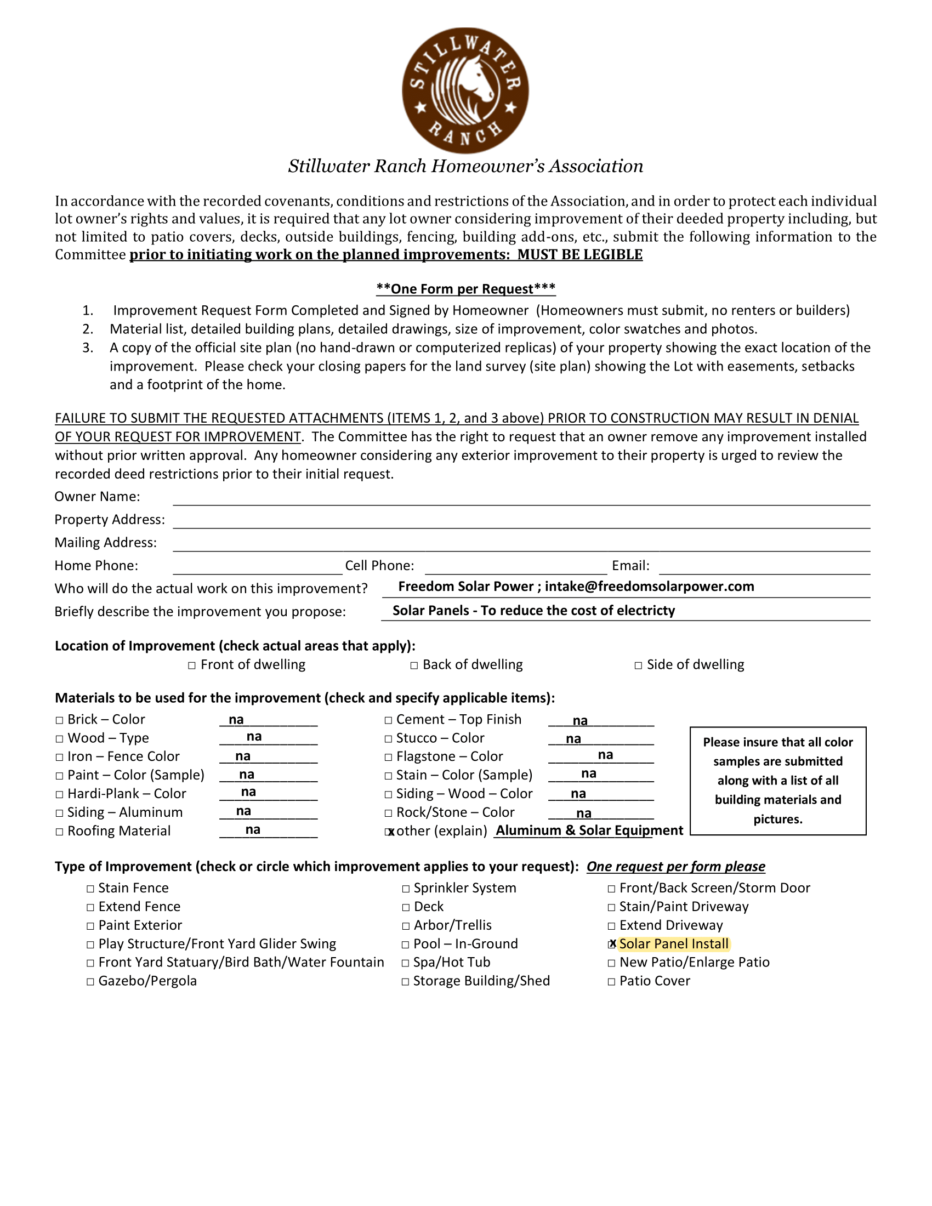

{{email}}

{{phone}}

{{phone}}

{{address}}

{{address}}

{{name}}

{{date}}

{{name}}

Solar Panels install

{{address}}

{{date}}

Freedom Solar Power